**Chapter 4: System Description**

**4.1 Design**

**Block Diagram:**

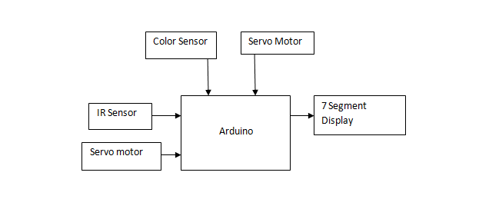

Serial Monitor

Figure 4.1: Block Diagram of Color-Sorting Project

The above block diagram describes how the components of this IoT project will be connected. Two sensors will be used, namely the color sensor TCS3200 which will help detect color of the objects and an IR Sensor which will be used to count the number of objects. These two sensors will be used to accept input. The rotation of the objects towards the color sensor as well as dropping the object in its respective containers using a conveyer will be done using a Servo Motor. The output for the count will be displayed on a 7 segment display and the output for the Color Sensor will be displayed on the serial monitor.

**4.2 Hardware, Software and cloud platforms used**

**Components requirements:**

1. Arduino:

The Arduino MEGA 2560 is designed for projects that require more I/O lines, more sketch memory and more RAM. With 54 digital I/O pins, 16 analog inputs and a larger space for your sketch it is the recommended board for 3D printers and robotics projects. This gives your projects plenty of room and opportunities maintaining the simplicity and effectiveness of the Arduino platform. This document explains how to connect your Mega2560 board to the computer and upload your first sketch. The Arduino Mega 2560 is programmed using the Arduino Software (IDE), our Integrated Development Environment common to all our boards and running both online and offline. For more information on how to get started with the Arduino Software visit the Getting Started page.

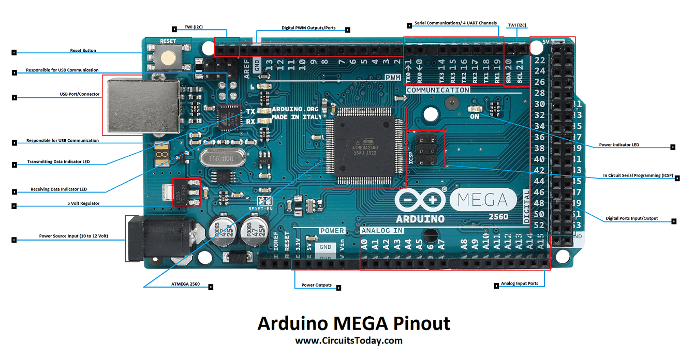 

Figure 4.2: Arduino Mega 2560 hardware Figure 4.3: Arduino Software

2. TCS 3200 Color sensor:

TCS3200-DB Color Sensor Daughterboard is a complete color detector, including a TAOS TCS3200 RGB sensor chip, white LEDs, collimator lens, and standoffs to set the optimum sensing distance. The TCS3200 has an array of photodetectors, each with either a red, green, or blue filter, or no filter (clear). The filters of each color are distributed evenly throughout the array to eliminate location bias among the colors. Internal to the device is an oscillator which produces a square-wave output whose frequency is proportional to the intensity of the chosen color. The applications of color sensor are Test strip reading, sorting by color, Ambient light sensing and calibration, Color matching.

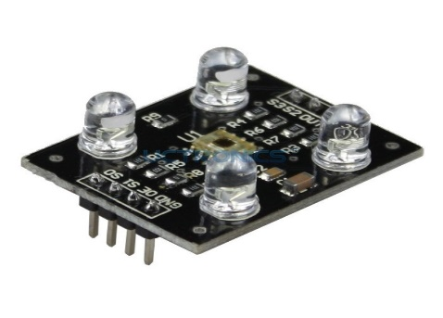

Figure 4.4: Color Sensor TCS3200

3. IR Sensor (LM393)

* Working voltage: 3 - 5V DC
* Output type: Digital switching output (0 and 1)
* 3mm screw holes for easy mounting
* Board size: 3.2 x 1.4cm [4]

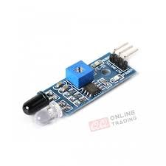

Figure 4.5: IR sensor (LM393)

4. Servo motor:

A servomotor is a rotary actuator or linear actuator that allows for precise control of angular or linear position, velocity and acceleration. It consists of a suitable motor coupled to a sensor for position feedback. It also requires a relatively sophisticated controller, often a dedicated module designed specifically for use with servomotors. Servomotors are not a specific class of motor, although the term servomotoris often used to refer to a motor suitable for use in a closed-loop control system. Servomotors are used in applications such as robotics, CNC machinery or automated manufacturing. The Specifications of servo motor are mentioned below

* Operating voltage: 4.8 V (~5V)
* Operating speed: 0.1 s/60 degree
* Stall torque: 1.8 kgf·cm
* Dead band width: 10 µs
* Temperature range: 0 ºC – 55 ºC [16]

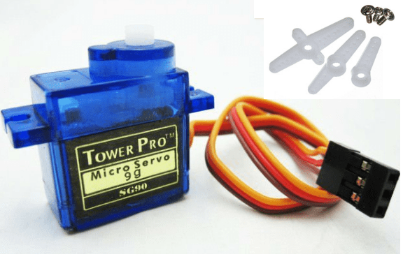

Figure 4.6: Servo Motors

5. Fiber board:

Fiberboard (or fiberboard) is a type of engineered wood product that is made out of wood fibers. Types of fiberboard (in order of increasing density) include particle board or low-density fiberboard (LDF), medium-density fiberboard (MDF), and hardboard (high-density fiberboard, HDF). It is sometimes used as a synonym for particle board, but particle board usually refers to low-density fiberboard. Plywood is not a type of fiberboard, as it is made of thin sheets of wood, not wood fibers or particles. Fiberboard, particularly medium-density fiberboard, is heavily used in the furniture industry. For pieces that will be visible, a veneer of wood is often glued onto fiberboard to give it the appearance of conventional wood. In the packaging industry, the term "fiberboard" is often used to describe a tough Kraft-based paperboard or corrugated fiberboard for boxes. "Fiberboard" is also an intermediate product, an output of a pulp mill used as input for a paper mill.

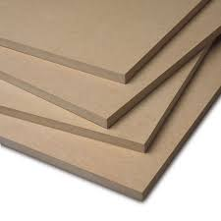

Figure 4.7: Fiber board

6. Colored objects:

We will be using colored objects for sorting and testing the prototype.



Figure 4.8: Colored Objects

**4.3 Implementation Methodology**

We first observed the problem and planned to implement our project according to it. We also noted various additional things we can add into our project which can make the work of industry owners simple. To implement the color sorting machine and count we followed the following steps:

Step 1: We planned what all facilities are we going to provide the user and gathered all the required hardware and software according to it.

Step 2: Implementing one sensor at a time, we tested our code and saw if we got the desired output. Initially we started with easy to implement sensors like IR Sensor and then went onto implement the color sensor.

* IR Sensor: We have to implement one IR Sensor in this project to count the number of objects being produced. IR Sensor has 3 pins. We connect the IR Sensor to the Arduino Board. Then we burn our code to the Arduino board which executes our logic of counting the number of objects produced. That count is displayed on our serial monitor to keep track of the objects. According to our logic implemented,

0 objects → count is not affected.

1 or more object → the number of objects is counted.

* Color Sensor: We have to implement one color sensor in our project which will check the color of the object and help us in sorting objects produced in bulk. The code is run on Arduino board which executes the logic of how the objects are sorted. The sensor sorts 3 colors namely red, blue and green. Accordingly the object is sent to respective bin.

Logic:-

|  |  |  |
| --- | --- | --- |
| S2 | S3 | Color Detected |
| LOW | LOW | RED |
| HIGH | HIGH | GREEN |
| LOW | HIGH | BLUE |

Table 4.1: Logic Table for Color Sensor

Step 3: Building the Prototype:

* First we bought the fiber board and cut it into pieces of respective size.
* Then we decided the placement of the respective sensors.
* First we fixed the IR Sensor which would help us count the number of objects
* Then the color sensor was placed.
* We tested and inserted the Servo Motors for the conveyer.
* We kept respective bins for the colored objects.

**4.4 Hardware circuit diagram**

**4.5 Code**

**Code for IR Sensor:-**

To count the number of objects using IR Sensor.

Display is shown on the serial monitor in arduino

Code for IR Sensor:

int LED = 13; // Use the onboard Uno LED

int obstaclePin = 7; // This is our input pin

int hasObstacle = HIGH; // HIGH MEANS NO OBSTACLE

int counter = 0;//initialize counter as 0

int i = 0;

void setup() {

pinMode(LED, OUTPUT);

pinMode(obstaclePin, INPUT);

Serial.begin(9600);

}

void loop() {

hasObstacle = digitalRead(obstaclePin); //Reads the output of the obstacle sensor from the 7th PIN of the Digital section of the arduino

if (hasObstacle == LOW) //LOW means something is ahead, so illuminates the 13th Port connected LED

{

Serial.println("Stop something is ahead!!");

counter = counter+1;

Serial.println(counter);

digitalWrite(LED, HIGH);//Illuminates the 13th Port LED

}

else

{

Serial.println("Path is clear");

digitalWrite(LED, LOW);

}

delay(200);

}

Code for Color Sensor TCS3200

// TCS230 or TCS3200 pins wiring to Arduino

#define S0 4

#define S1 5

#define S2 6

#define S3 7

#define sensorOut 8

// Stores frequency read by the photodiodes

int redFrequency = 0;

int greenFrequency = 0;

int blueFrequency = 0;

void setup() {

// Setting the outputs

pinMode(S0, OUTPUT);

pinMode(S1, OUTPUT);

pinMode(S2, OUTPUT);

pinMode(S3, OUTPUT);

// Setting the sensorOut as an input

pinMode(sensorOut, INPUT);

// Setting frequency scaling to 20%

digitalWrite(S0,HIGH);

digitalWrite(S1,LOW);

// Begins serial communication

Serial.begin(9600);

}

void loop() {

// Setting RED (R) filtered photodiodes to be read

digitalWrite(S2,LOW);

digitalWrite(S3,LOW);

// Reading the output frequency

redFrequency = pulseIn(sensorOut, LOW);

// Printing the RED (R) value

Serial.print("R = ");

Serial.print(redFrequency);

delay(100);

// Setting GREEN (G) filtered photodiodes to be read

digitalWrite(S2,HIGH);

digitalWrite(S3,HIGH);

// Reading the output frequency

greenFrequency = pulseIn(sensorOut, LOW);

// Printing the GREEN (G) value

Serial.print(" G = ");

Serial.print(greenFrequency);

delay(100);

// Setting BLUE (B) filtered photodiodes to be read

digitalWrite(S2,LOW);

digitalWrite(S3,HIGH);

// Reading the output frequency

blueFrequency = pulseIn(sensorOut, LOW);

// Printing the BLUE (B) value

Serial.print(" B = ");

Serial.println(blueFrequency);

delay(100);

}

**4.6 Final Prototype**

**4.7 Conclusion and Future scope of the project**

**Conclusion:**

The proposed project provides a color sorting machine with the ability to also count the number of objects produced. This helps us have a two in one machine and the working of this model is much easier as compared to other bulky industrial machines due to its features and compact size.

**Future Scope:**

* A robotic arm can be used to pick and place objects which can make the working of the project faster.
* The sensors can be modified to not only match the needs of color sorting but also distinguish between various other objects.
* It can be made more durable by using better quality materials.
* Large industries associated with color sorting can use this project to reduce bulky machinery in their workspace causing the working area to be more organized and provide larger amount of space for mobility.

**4.8 Constraints for real time deployment**

* Arduino Board: Even though this project could be implemented with Arduino Mega board, it is a small scale project. If this project is to be implemented on a large scale, the Arduino Mega board will fall short due to less number of pins and processing capabilities.
* IR Sensor: IR sensors used here have a small capability of detecting objects and they have a small range to detect objects in the environment. For large scale, IR sensors with a greater detection range and performance will have to be used.
* Cost: If this machine needs to be implemented in a real time industry, the net cost will be much higher.
* Sorting objects: In this project only particular objects can be sorted keeping in mind the size and other specifications of the objects.